High School Academic Success and College Graduation
Student
April 25, 2018
Table of Contents
Section I: Introduction 1
Section II: Exploratory Data Analysis 2
Section III: Simple Linear Regression 14
Section IV: Multiple Linear Regression 18
Section V: Hypothesis Testing 25
Section VI: Conclusions 26
Honor Code 27

Section I: Introduction
This project will use the dataset College from the ISLR package. The data collected comes from the 1995 issue of US News and World Report. It contains 777 observations and 18 variables: Private, Apps, Accept, Enroll, Top10perc, Top25perc, F.Undergrad, P.Undergrad, Outstate, Room.Board, Books, Personal, PhD, Terminal, S.F. Ratio, perc.alumni, Expend, Grad.Rate. These 18 variables give information about various aspects of 777 colleges in the U.S., such as tuition fees, students accepted, students enrolled, etc.
The research question in this project is “Does high school academic success predict college completion?” This project attempts to examine the effects of various factors on graduation rates of 777 colleges in the U.S. The dependent variable that will be used to measure college completion is Grad.Rate. This variable refers to the percentage of students that graduated from the 777 colleges included in the dataset in 1995. The primary independent variables that will be used to measure high school academic success are Top10perc and Top25perc. The former refers to the percentage of students who were in the top 10 percent of their high school class. The latter refers to the percentage of students that were in the top 25 percent of their high school class. For this project, the independent variables of Private and Outstate will also be used. The Private variable refers to whether an observation is a private university or a public university. The Outstate variable refers to the out-of-state tuition fees for each college in the dataset. These two independent variables will be used to add an extra element to the research question by examining the relationship of the type of school and fees with graduation rate. In other words, we can observe whether the type of school and its fees have higher or lower graduation rates. Logically, it is expected that universities that accept more students that were academically successful in high school would have higher graduation rates. This may be due to the fact that these students stay on-track in college as well, and graduate on time. In addition, it may seem that private schools tend to have higher graduation rates than those of public schools, perhaps due to more individualized attention or selectivity of students.

Section II: Exploratory Data Analysis
Univariate and bivariate analyses can be conducted to examine the independent and dependent variables of this project. Univariate analysis will help illustrate each of the variables individually. It can allow us to look at measures of central tendency such as mean, median, and standard deviation.
Bivariate analysis will provide graphical representations of the data to help illuminate the relationship between the various independent variables and the dependent variable. It also helps us understand the strength between the relationships through correlation.
hist(College$Grad.Rate, col= "turquoise", ylim= c(0,200), xlab= "Graduation Rate (%)", main= "Graduation Rate Histogram")
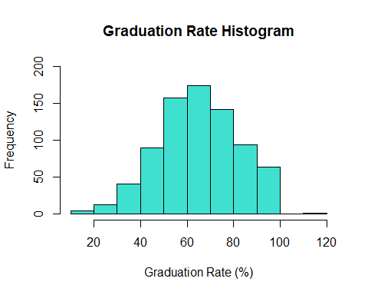
boxplot(College$Grad.Rate, col= "turquoise", xlab= "Graduation Rate (%)", horizontal = TRUE, main= "Graduation Rate Boxplot")
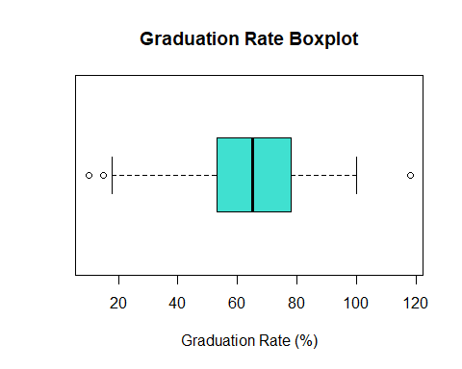
mean(College$Grad.Rate)
## [1] 65.46332
median(College$Grad.Rate)
## [1] 65
diff(range(College$Grad.Rate))
## [1] 108
IQR(College$Grad.Rate)
## [1] 25
var(College$Grad.Rate)
## [1] 295.0737
sd(College$Grad.Rate)
## [1] 17.17771
quantile(College$Grad.Rate)
## 0% 25% 50% 75% 100%
## 10 53 65 78 118
summary(College$Grad.Rate)
## Min. 1st Qu. Median Mean 3rd Qu. Max.
## 10.00 53.00 65.00 65.46 78.00 118.00
The variable Grad.Rate is the dependent variable in this project. It refers to the percentage of students that graduated from their respective universities in 1995. The mean graduation rate is 65.46%. This means that, on average, 65.46% of students graduated from the 777 colleges in this dataset in 1995. The median rate is 65%, which is very close to the mean. The median divides the overall distribution into two equal parts. The minimum graduation rate was 10%, at Texas Southern University. This means that at that particular university, only 10% of students graduated in 1995. The maximum graduation rate was 118%, at Cazenovia College. These minimum and maximum values make the range 108. The interquartile range refers to the difference between the third and first quartiles in a bell-shaped curve. In a boxplot, this refers to all the values within the box. 50% of the data is within the interquartile range. In terms of graduation rate, the value of the first quartile is 53 and the value of the third quartile is 78, so the IQR is 25. This means that 53-78% of students attending half of these universities graduated in 1995. The variance refers to how far each number in a set deviates from the mean. With Grad.Rate, the variance is 295.0737. The standard deviation puts this large number into better terms by taking the square root of the variance. The standard deviation here is 17.18.
hist(College$Top10perc, col= "slateblue1", ylim= c(0,250), xlab = "Students in the Top 10% (%)", main= "Top 10% Histogram")
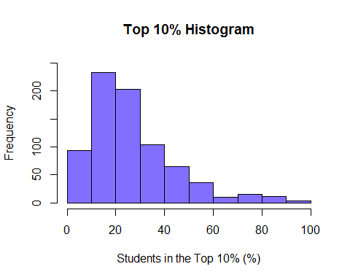
boxplot(College$Top10perc, col= "slateblue1", horizontal = TRUE, xlab = "Students in the Top 10% (%)", main= "Top 10% Boxplot")
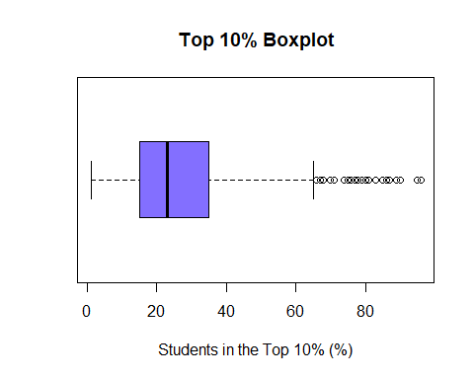
mean(College$Top10perc)
## [1] 27.55856
median(College$Top10perc)
## [1] 23
diff(range(College$Top10perc))
## [1] 95
IQR(College$Top10perc)
## [1] 20
var(College$Top10perc)
## [1] 311.1825
sd(College$Top10perc)
## [1] 17.64036
quantile(College$Top10perc)
## 0% 25% 50% 75% 100%
## 1 15 23 35 96
summary(College$Top10perc)
## Min. 1st Qu. Median Mean 3rd Qu. Max.
## 1.00 15.00 23.00 27.56 35.00 96.00
The variable Top10perc is an independent variable in this project. It refers to the percent of students attending various universities that were in the top 10% of their high school class. The mean is 27.6%. This means that 27.6% of students attending universities included in this dataset were in the top 10% of their high school class. The median is 23%, which is close to mean. 96% of students at Massachusetts Institute of Technology were in the top 10% of their high school class. This is the highest percentage in the dataset, making it the maximum value. The minimum value in this dataset is 1, meaning that only 1% percent of students in the top 10% of their high school class attended a particular university. These two values of 96 and 1 give us the range of 95. The value of the first quartile is 15 and the value of the third quartile is 35, giving an interquartile range of 20. This means that 15-35% of students attending half of these universities were in the top 10% of their high school class. The variance is 311.18 and the standard deviation is 17.64. With this standard deviation, it appears that the data points are somewhat close to the mean and do not deviate too far.
hist(College$Top25perc, col= "plum", ylim= c(0,250), xlab = "Students in the Top 25% (%)", main= "Top 25% Histogram")
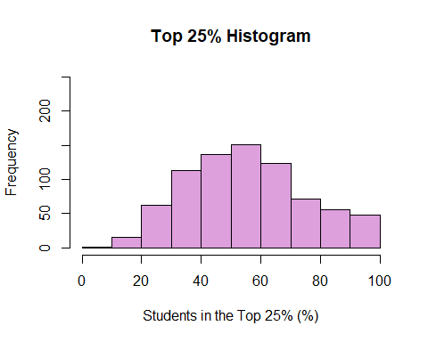
boxplot(College$Top25perc, col= "plum", horizontal = TRUE, main= "Top 25% Boxplot", xlab = "Students in the Top 25% (%)")
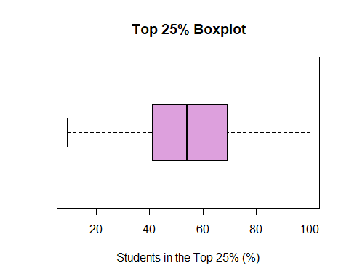
mean(College$Top25perc)
## [1] 55.79665
median(College$Top25perc)
## [1] 54
diff(range(College$Top25perc))
## [1] 91
IQR(College$Top25perc)
## [1] 28
var(College$Top25perc)
## [1] 392.2292
sd(College$Top25perc)
## [1] 19.80478
quantile(College$Top25perc)
## 0% 25% 50% 75% 100%
## 9 41 54 69 100
summary(College$Top25perc)
## Min. 1st Qu. Median Mean 3rd Qu. Max.
## 9.0 41.0 54.0 55.8 69.0 100.0
The variable Top25perc is very similar to the Top10perc variable. It is also an independent variable, and refers to the percentage of students attending various universities that were in the top 25% of their high school class. The mean is 55.79, which means that a little over half of the students attending the universities in this dataset were in the top 25% of their high school class. Once again, the median is very close to the mean, at 54. The maximum value with this variable is 100, meaning that at a particular university, 100% of its students were in the top 25% of their high school class. The minimum value is 9. These two values give a range of 91. The value of the first quartile is 41, and the value of the third quartile is 69. This results in an interquartile range of 28. This means that 41-69% of students attending half of these universities were in the top 25% of their high school class. The variance is 392.2292, and the standard deviation is 19.8. With this variable, the data points deviate a little more from the mean than the Top10perc variable.
hist(College$Outstate, col= "springgreen4", ylim= c(0, 150), xlab = "Out-of-State Tuition ($)", xlim= c(0,25000), main= "Out-of-State Tuition Histogram")
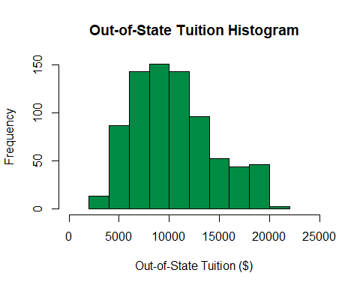
boxplot(College$Outstate, col= "springgreen4", horizontal = TRUE, xlab= "Out-of-State Tuition ($)", main= "Out-of-State Tuition Boxplot")
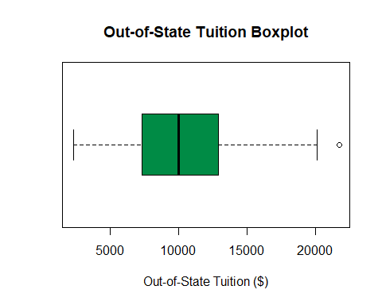
mean(College$Outstate)
## [1] 10440.67
median(College$Outstate)
## [1] 9990
diff(range(College$Outstate))
## [1] 19360
IQR(College$Outstate)
## [1] 5605
var(College$Outstate)
## [1] 16184662
sd(College$Outstate)
## [1] 4023.016
quantile(College$Outstate)
## 0% 25% 50% 75% 100%
## 2340 7320 9990 12925 21700
summary(College$Outstate)
## Min. 1st Qu. Median Mean 3rd Qu. Max.
## 2340 7320 9990 10441 12925 21700
The Outstate variable refers to the out-of-state tuition (in dollars) for 777 colleges. The mean is 10,440.67, which is the average cost for out-of-state tuition. The median, is somewhat close, at 9,990. The maximum value is 21,700, which means that the highest out-of-state tuition is $21,700. The minimum value is 2,340. As a result, the range is 19,360. The value of the third quartile is 12,920, and the value of the first quartile is 7,320. This gives us the interquartile range of 5,605. This means that half of the universities in this dataset have an out-of-state tuition between $7,320 and $12,920. The variance is 16184662, and the standard deviation is 4023.016. While this standard deviation seems much larger than those of the previous variables, it is important to note that the units for this variable are different from those of previous: dollars instead of percentages.
private <- table(College$Private)
barplot(private, col= "Maroon", main= "Type of University", xlab= "Private?")
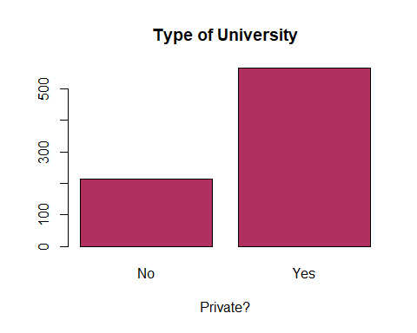
private
##
## No Yes
## 212 565
The Private variable in this project is also an independent variable. It is a categorical variable, because universities can either be public (government-funded) or private (not goverment-funded). In this particular dataset, 212 universities are public, and 565 are private. This means that approximately 27% are public and 73% are private. There are more private universities than public universities in this dataset.
Now we can delve into bivariate analysis to observe the relationships between Grad.Rate and four independent variables.
plot(College$Grad.Rate ~ College$Top10perc, xlim= c(0,100), col= "slateblue1", xlab= "Top 10% of High School Class (%)", ylab= "Graduation Rate (%)", main="Top 10% and Graduation Rate")
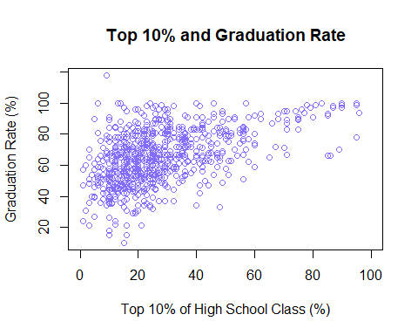
cov(College$Grad.Rate, College$Top10perc)
## [1] 149.9922
cor(College$Grad.Rate, College$Top10perc)
## [1] 0.4949892
Creating a scatterplot of the Grad.Rate and Top10perc demonstrates a slightly positive correlation between the two variables. This means that schools that have a larger percentage of students attending that were in the top 10% of their high school class might have slightly higher graduate rates than those that have less of these students attending. This can be validated by the covariance, which is 149.9922. Because this number is positive, it can be said that there is a positive relationship between the two variables. To get a sense of the degree to which these two variables are related, the correlation can be found. In this case, the correlation is 0.4949892, so the relationship between these two variables is slightly positive. It is important to note that correlation does not imply causation. These scatterplots simply demonstrate a relationship between two variables.
plot(College$Grad.Rate ~ College$Top25perc, xlab= "Top 25% of High School Class (%)", ylab= "Graduation Rate (%)", col= "plum", main="Top 25% and Graduation Rate")
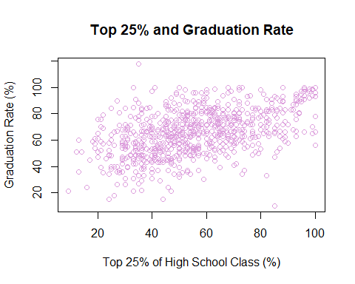
cov(College$Grad.Rate, College$Top25perc)
## [1] 162.3714
cor(College$Grad.Rate, College$Top25perc)
## [1] 0.4772812
A scatterplot of Grad.Rate and Top25perc also demonstrates a slightly positive relationship. The covariance is 162.3714, and the correlation is 0.4772812. This means that there is a relationship between schools that have a larger percentage of students attending that were in the top 25% of their high school class and increased graduation rates.
plot(College$Grad.Rate ~ College$Outstate, xlab= "Out-of-State Tuition ($)", ylab= "Graduation Rate (%)", col= "springgreen4", main= "Out-of-State Tuition and Graduation Rate")
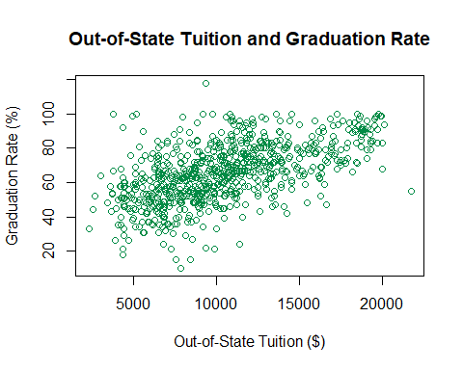
cov(College$Grad.Rate, College$Outstate)
## [1] 39479.68
cor(College$Grad.Rate, College$Outstate)
## [1] 0.5712899
A scatterplot between Grad.Rate and Outstate illustrates a slightly positive relationship. The covariance is 39479.68, and the correlation is 0.5712899. This means that there is a positive relationship between universities with higher out-of-state tuition and graduation rates.
boxplot(College$Grad.Rate ~ College$Private, data=College, ylim= c(0,120), xlab= "Private?", ylab= "Graduation Rate (%)", col= "Maroon", main= "Type of University and Graduation Rate")
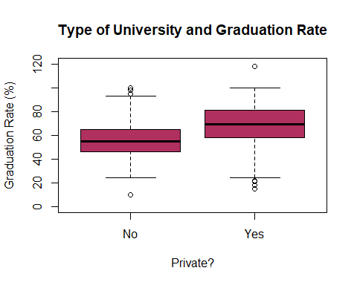
This is a boxplot of Grad.Rate and Private. It appears that private universities tend to have higher graduation rates overall compared to public universities.

Section III: Simple Linear Regression
As a reminder, this project aims to look at the effects of various factors on graduation rates of 777 colleges in 1995. Specifically, the research question is “Does high school academic success predict college completion?” Linear regressions will be performed to examine whether the variable Top10perc and Private can predict higher graduation rates. Looking at the correlations from before, it seems that there are slightly positive correlations between Grad.Rate and Top10perc, and Grad.Rate and Private. Interpretations of the simple linear regressions are below.
plot(College$Grad.Rate ~ College$Top10perc, xlim= c(0,100), col= "slateblue1", xlab= "Top 10% of High School Class (%)", ylab= "Graduation Rate (%)", main="Top 10% and Graduation Rate")
Top10 <- lm(College$Grad.Rate ~ College$Top10perc, College)
abline(Top10)
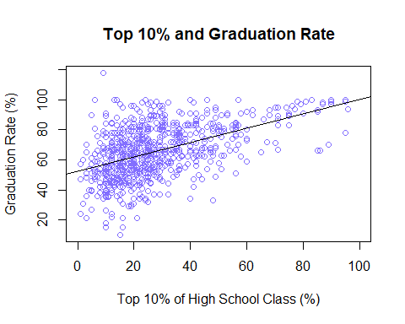
Top10
##
## Call:
## lm(formula = College$Grad.Rate ~ College$Top10perc, data = College)
##
## Coefficients:
## (Intercept) College$Top10perc
## 52.180 0.482
summary(Top10)
##
## Call:
## lm(formula = College$Grad.Rate ~ College$Top10perc, data = College)
##
## Residuals:
## Min 1Q Median 3Q Max
## -49.410 -9.834 0.288 9.080 61.482
##
## Coefficients:
## Estimate Std. Error t value Pr(>|t|)
## (Intercept) 52.17990 0.99431 52.48 <2e-16 ***
## College$Top10perc 0.48201 0.03039 15.86 <2e-16 ***
## ---
## Signif. codes: 0 '***' 0.001 '**' 0.01 '*' 0.05 '.' 0.1 ' ' 1
##
## Residual standard error: 14.94 on 775 degrees of freedom
## Multiple R-squared: 0.245, Adjusted R-squared: 0.244
## F-statistic: 251.5 on 1 and 775 DF, p-value: < 2.2e-16
Estimated Regression Line: yhat = 52.17990 + 0.48201x
The Top10perc variable in the College dataset gives the percent of students attending a particular university that were in the top 10% of their high school class. This variable is extremely relevant to the research question, because it demonstrates high school academic success. After running a simple linear regression, a y-intercept of 52.17990 and a slope of 0.48201 are obtained. This slope shows us that a 1 unit increase in the percentage of students attending a university that were in the top 10% of their high school class results in a 0.48201 increase in the graduation rate of that particular university. The Multiple R-Squared is the coefficient of determination. It allows us to examine the predictive power of the variable. Values closer to 1 indicate good predictive power, while values closer to 0 indicate little predictive power. In this case, the Multiple R-Squared is 0.245, indicating a low predictive power. While there is a positive correlation between Top10perc and Grad.Rate, it does not mean that a higher graduation rate is caused by a higher number of students attending a particular university that were in the top 10% of their high school class. Correlation does not imply causation.
is.factor(College$Private)
## [1] TRUE
Privatelm <- lm(College$Grad.Rate ~ College$Private, data=College)
Privatelm
##
## Call:
## lm(formula = College$Grad.Rate ~ College$Private, data = College)
##
## Coefficients:
## (Intercept) College$PrivateYes
## 56.04 12.96
summary(Privatelm)
##
## Call:
## lm(formula = College$Grad.Rate ~ College$Private, data = College)
##
## Residuals:
## Min 1Q Median 3Q Max
## -53.998 -10.042 0.002 11.002 49.002
##
## Coefficients:
## Estimate Std. Error t value Pr(>|t|)
## (Intercept) 56.042 1.112 50.406 <2e-16 ***
## College$PrivateYes 12.956 1.304 9.937 <2e-16 ***
## ---
## Signif. codes: 0 '***' 0.001 '**' 0.01 '*' 0.05 '.' 0.1 ' ' 1
##
## Residual standard error: 16.19 on 775 degrees of freedom
## Multiple R-squared: 0.113, Adjusted R-squared: 0.1119
## F-statistic: 98.74 on 1 and 775 DF, p-value: < 2.2e-16
boxplot(College$Grad.Rate ~ College$Private, data=College, ylim= c(0,120), xlab= "Private?", ylab= "Graduation Rate (%)", col= "Maroon", main= "Type of University and Graduation Rate")
abline(Privatelm)
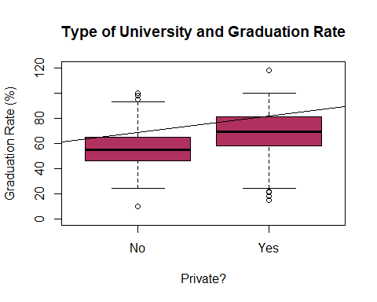
The Private variable is a categorical variable that indicates whether a university (observation) is private or public. Public universities are coded as No, while private universities are coded as Yes.
This variable adds an extra element to the research question by illustrating a relationship between private schools and higher graduation rates. After running a simple linear regression, we can see that the intercept is 56.04. This means that public universities have an average graduation rate of 56.04%. Private universities, however, have an average graduation rate of 69%, which is approximately 13% higher than that of public universities. This idea that private universities have higher graduation rates than those of public universities is also evident through the horizontal line running through the boxplots. The line crosses the No boxplot at a lower value, while it crosses the Yes boxplot at a higher value. It is important to note that the type of university (public or private) is not an accurate predictor of graduation rates. This is evident from the Multiple R-Squared of 0.113. It solidifies the idea that the variable “Private” has little predictive power. Attending a private university does not necessarily guarantee higher graduation rates.
Neither Top10perc nor Private have significant predictive power in graduation rates. The Multiple R-Squared for Top10perc was 0.245, and the Multiple R-Squared for Private was 0.113. Given these two values, Top10perc seems to have a slightly higher predictive power than Private, but is still not very significant.
One reason the Multiple R-Squared might be so low is because the response variable is looking at human behavior, which can be extremely difficult to predict. It is tough to predict the percentage of students that will be graduating from a particular university in a particular year. This number can vary greatly, depending on a variety of outside factors.

Section IV: Multiple Linear Regression
Two multiple linear regression models are presented below, but the second model is much more interesting to assess and analyze because it takes into account the type of university and its effect on college graduation rates as well. Explanation of the second model also includes formal tests of hypotheses.
lm1 <- lm(Grad.Rate ~ Top10perc + Top25perc, data = College)
summary(lm1)
##
## Call:
## lm(formula = Grad.Rate ~ Top10perc + Top25perc, data = College)
##
## Residuals:
## Min 1Q Median 3Q Max
## -55.750 -9.754 0.321 9.330 61.818
##
## Coefficients:
## Estimate Std. Error t value Pr(>|t|)
## (Intercept) 47.90061 1.95282 24.529 < 2e-16 ***
## Top10perc 0.33003 0.06700 4.926 1.03e-06 ***
## Top25perc 0.15176 0.05968 2.543 0.0112 *
## ---
## Signif. codes: 0 '***' 0.001 '**' 0.01 '*' 0.05 '.' 0.1 ' ' 1
##
## Residual standard error: 14.88 on 774 degrees of freedom
## Multiple R-squared: 0.2513, Adjusted R-squared: 0.2493
## F-statistic: 129.9 on 2 and 774 DF, p-value: < 2.2e-16
Model 1
Y = B0 + B1x1 + B2x2
This multiple linear regression looks at the effects of high school academic success on graduation rates. Once again, high school academic success in this project is defined as students in the top 10% or 25% of their high school class. A one unit increase in top10perc results in a 0.33003 increase in graduation rate, holding the Top25perc variable constant. A one unit increase in top25perc results in a 0.15176 increase in graduation rate, holding the Top10perc variable constant. Looking at the p-values, both explanatory variables have values less than the significance level of 0.05, so it can be safe to say that both variables are statistically significant. There is a significant relationship between Top10perc and Grad.Rate, and there is a significant relationship between Top25perc and Grad.Rate. This means that high school academic success has a significant association with graduation rates. The amount of variation in graduation rate that is explained by this model is 0.2513, which means that this model has very little predictive power.
To examine the added effect of the type of university on graduation rates, it may be beneficial to add the variable Private to the aforementioned regression. This multiple linear regression may be better than the previous due to the addition of the Private variable, and all the variables are significant at the 0.05 confidence level.
lm2 <- lm(Grad.Rate ~ Top10perc + Top25perc + factor(Private), data = College)
summary(lm2)
##
## Call:
## lm(formula = Grad.Rate ~ Top10perc + Top25perc + factor(Private),
## data = College)
##
## Residuals:
## Min 1Q Median 3Q Max
## -51.072 -9.246 -0.008 8.950 58.246
##
## Coefficients:
## Estimate Std. Error t value Pr(>|t|)
## (Intercept) 39.74890 2.06192 19.278 < 2e-16 ***
## Top10perc 0.22701 0.06471 3.508 0.000478 ***
## Top25perc 0.21080 0.05712 3.690 0.000240 ***
## factor(Private)Yes 10.58421 1.16316 9.100 < 2e-16 ***
## ---
## Signif. codes: 0 '***' 0.001 '**' 0.01 '*' 0.05 '.' 0.1 ' ' 1
##
## Residual standard error: 14.15 on 773 degrees of freedom
## Multiple R-squared: 0.3237, Adjusted R-squared: 0.3211
## F-statistic: 123.3 on 3 and 773 DF, p-value: < 2.2e-16
Model 2
Y = B0 + B1x1 + B2x2 + B3x3
Hypothesis Testing
B1 corresponds to Top10perc
H0: Beta1 = 0
The null hypothesis is that there is no significant relationship between students attending a university that were in the top 10% of their high school class and college graduation rate, holding all other variables fixed.
H1: Beta1 ne = 0
The alternative hypothesis is that there is a relationship between students that attend a university that were in the top 10% of their high school class and college graduation rate, holding all other variables fixed.
B2 corresponds to Top25perc
H0: Beta2 = 0
The null hypothesis is that there is no relationship between students that attend a university that were in the top 25% of their high school class and college graduation rate, holding all other variablex fixed.
H1: Beta2 ne = 0
The alternative hypothesis is that there is a relationship between students that attend a university that were in the top 25% of their high school class and college graduation rate, holding all other variables fixed.
B3 corresponds to Private
H0: Beta3 = 0
The null hypothesis for the variable Private is that there is no effect of Private on Grad.Rate, holding all other variables fixed.
H1: Beta3 ne 0
The alternative hypothesis for this variable is that there is some effect of Private on Grad.Rate, holding all other variables fixed.
Interpretation
Holding the other predictors constant, a 1 unit increase in the percentage of students attending a particular university that were in the top 10% of their high school class results in a 0.22701 increase in graduation rate. The p-value for Top10perc is very small, at 0.000478. This means the null hypothesis can be rejected, and it can be concluded that there is a significant relationship between students that attend a university that were in the top 10% of their high school class and college graduation rate.
Holding the other predictors constant, a 1 unit increase in the percentage of students attending a particular university that were in the top 25% of their high school class results in a 0.21080 increase in graduation rate. The p-value for this variable is also very small, at 0.000240. Once again, at the 0.05 significance level, we can reject the null hypothesis and conclude that there is a significant relationship between Top25perc and Grad.Rate.
Holding the other predictors constant, there is a 39.75% graduation rate at public schools. We can adjust this baseline coefficient to examine the increase in graduation rate at private schools by 10.58421. This means that the overall graduation rate increases by 10.58% at private schools. The p-value for this variable is 2e-16, so the null hypothesis can be rejected in favor of the alternative hypothesis. This means that there is some effect of the type of university on graduation rate.
This multiple linear regression model can also be compared to the simple linear regression models performed in section III of this project. The simple linear regression between Top10perc and Grad.Rate and Private and Grad.Rate, both have lower r-squared values than the multiple linear regression model. This may mean that the multiple linear regression model examining the effect of Top10perc, Top25perc, and Private on Grad.Rate has more predictive power.
Conclusion
The p-values for Top10perc, Top25perc, and Private were all significant at the 0.05 level, meaning that all three factors have a significant effect on college graduate rate.
Model Assessment
As a reminder, the multiple R-squared is used to describe the amount of variation in Y that can be explained by X. A multiple R-squared number closer to 1 indicates high predictive power and a number closer to 0 indicates low predictive power. When comparing the two multiple linear regressions explained above, it is apparent that the second model has slightly higher predictive power. The multiple R-squared for the second model is 0.3237 (32%), while the multiple R-squared for the first model is 0.2513 (25%). Adding the Private variable slightly improves the fit by 0.0724 (7%). In other words, Top10perc, Top25perc, and Private explain 32.37% of the variability in Grad.Rate. It is important to note that 32.37% is somewhat low, so this model does not have high predictive power.
Residual Diagnosis
lm2 <- lm(Grad.Rate ~ Top10perc + Top25perc + factor(Private), data = College)
summary(lm2)
##
## Call:
## lm(formula = Grad.Rate ~ Top10perc + Top25perc + factor(Private),
## data = College)
##
## Residuals:
## Min 1Q Median 3Q Max
## -51.072 -9.246 -0.008 8.950 58.246
##
## Coefficients:
## Estimate Std. Error t value Pr(>|t|)
## (Intercept) 39.74890 2.06192 19.278 < 2e-16 ***
## Top10perc 0.22701 0.06471 3.508 0.000478 ***
## Top25perc 0.21080 0.05712 3.690 0.000240 ***
## factor(Private)Yes 10.58421 1.16316 9.100 < 2e-16 ***
## ---
## Signif. codes: 0 '***' 0.001 '**' 0.01 '*' 0.05 '.' 0.1 ' ' 1
##
## Residual standard error: 14.15 on 773 degrees of freedom
## Multiple R-squared: 0.3237, Adjusted R-squared: 0.3211
## F-statistic: 123.3 on 3 and 773 DF, p-value: < 2.2e-16
plot(lm2)
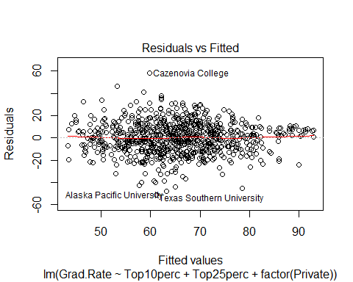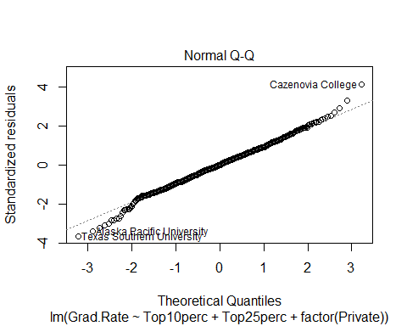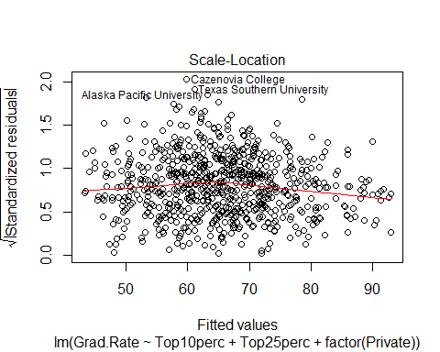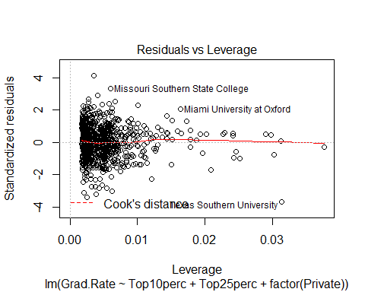
After conducting a linear regression, it is imperative to assess the validity of the model. Three assumptions of running a linear regression are linearity, normality, and constant variance.
The first plot is used to assess the linearity assumption and the independence of errors. A plot that meets this assumption should have randomly scattered points.For this regression, this plot seems to meet this assumption somewhat. The points are scattered randomly horizontally, but not vertically.
The second plot is used to assess the normality assumption, which describes the normal distribution of residuals. The values should fall along a straight and diagonal line. This plot seems to meet that assumption for the most part, with most of the points fitting on the line. There are a few near the bottom left and top right of the line that diverge, and may be problematic.
The third plot is used to assess the assumption of constant variance. Here, we are looking for randomly-scattered points. With this regression, the constant variance assumption is met. The points are randomly scattered throughout the graph.
The fourth plot can be used to examine potential outliers, which may be influencing the results. In this regression, there are a few outliers, namely Missouri Southern State College, Miami University at Oxford, and Texas Southern University.

Section V: Hypothesis Testing
Because Private is a categorical variable, a t-test can be performed to compare the means of Public university and Private university graduation rates. In this dataset, public universities are coded as No and private universities are coded as Yes.
The null hypothesis would be that the mean graduation rate of public universities is equal to the mean graduation rate of private universities. Another way to write this would be:
H0: muNo = muYes
The alternative hypothesis is that the mean graduation rate for public universities is not equal to the mean graduation rate for private universities. Another way to write this would be:
H1: muNo ne muYes
t.test(Grad.Rate ~ Private, data=College)
##
## Welch Two Sample t-test
##
## data: Grad.Rate by Private
## t = -10.579, df = 431.97, p-value < 2.2e-16
## alternative hypothesis: true difference in means is not equal to 0
## 95 percent confidence interval:
## -15.36276 -10.54880
## sample estimates:
## mean in group No mean in group Yes
## 56.04245 68.99823
The estimated mean graduation rate for public universities is 56%, and the estimated mean graduation rate for private universities is 69% (these values were also given in section III of this project). The level of significance for this t-test is 0.05. The p-value is 2.2e-16, so the null hypothesis can be rejected in favor of the alternative hypothesis.This means that there is a significant difference between the means of public and private university graduation rates. Another way to ensure that there is a significant difference between the two means is to look at the confidence interval. If the value of 0 is included in the confidence interval, the null hypothesis cannot be rejected, meaning that there is no significant difference between the two means. The lower bound of the 95% confidence interval is -15.36276, and the higher bound is -10.54880. In this case, the value of 0 is not included in the confidence interval, so the null hypothesis can be rejected, and it can be concluded that there is a significant difference between the two means. In other words, it can be said with 95% confidence that there is a statistical difference between these two means.

Section VI: Conclusions
The research question for this project was “Does high school academic success predict college completion?” My initial assumption was that universities with a larger number of students attending that were in the top 10 or 25 percent of their high school class would have higher graduation rates. This was assuming that these students are more driven and motivated to graduate on time. Throughout this project, I have seen that there is, in fact, a positive correlation between Top10perc/Top25perc and Grad.Rate. Through multiple linear regression, I was able to conduct formal tests of hypotheses to examine the significance of my predictors. I found that both Top10perc and Top25perc, as well as Private, were significant at the 0.05 level. It is important to note that while the p-values for my model were significant, the R-squared was rather low. The model I have found for this project is questionable due to this fact. It was still pretty interesting to examine and interpret the various plots and regressions conducted in this project.
While working on this project, I became increasingly fascinated with examining the differences in the graduation rates of public and private universities. While I conducted univariate and bivariate analyses of the Outstate variable, I was much more interested in the other three variables. This is due to my own curiosity in looking at the quality of students and education in relation to graduation rates, rather than the monetary value of a college education and graduation rates.
My initial assumption was that private universities would have higher graduation rates. This may be due to the fact that private universities have a more rigid structure and curriculum overall (at least from my experience). Through the linear regressions as well as the t-test, I was able to see that there was a significant difference between the graduation rates of private and public universities, which is consistent with my initial assumption.
One challenge I faced throughout the duration of this project was ensuring that I was interpreting the data correctly. However, I believe I was able to overcome this by referring to my notes and asking questions.
It would have been extremely interesting if this dataset included a variable that provided the average GPA of the graduating class at the 777 universities in 1995. With this variable, we would have been able to examine the relationship between high school academic success and college academic success. We would have been able to look at the relationship between universities that have a higher number of academically successful high school students attending and the average GPA of the graduating class.
I thoroughly enjoyed working on this project. As a college student myself, it was interesting to see the data for various universities and make sense of all the numbers. I liked analyzing the information and trying to find relationships between different variables.

Honor Code
On my honor, I have neither given nor received any unauthorized assistance on this work.
Student

